Object Detection using Gabor filter and Artificial Neural Network (ANN)
Jayesh Rathod ,(Advisor) Hassan S. Salehi, Ph.D.
Electrical Engineering,
University of Hartford,
Hartford ,CT
rathod@hartford.edu

Abstract— This Project present the Classification of two Object using the Machine Learning algorithm. Images is Filtered and features is taken using Gabor filter. Features of Image is feed to Artificial Neural Network which will Classify into two sector. Artificial Network Network is supervised learning here Data set will be given to get learned.Matlab software used for the simulation process.

I. Introduction
The main objective is Classification of data using advanced classification method, here machine learning is used for classification process. Image matrix is used as Classification Data here. 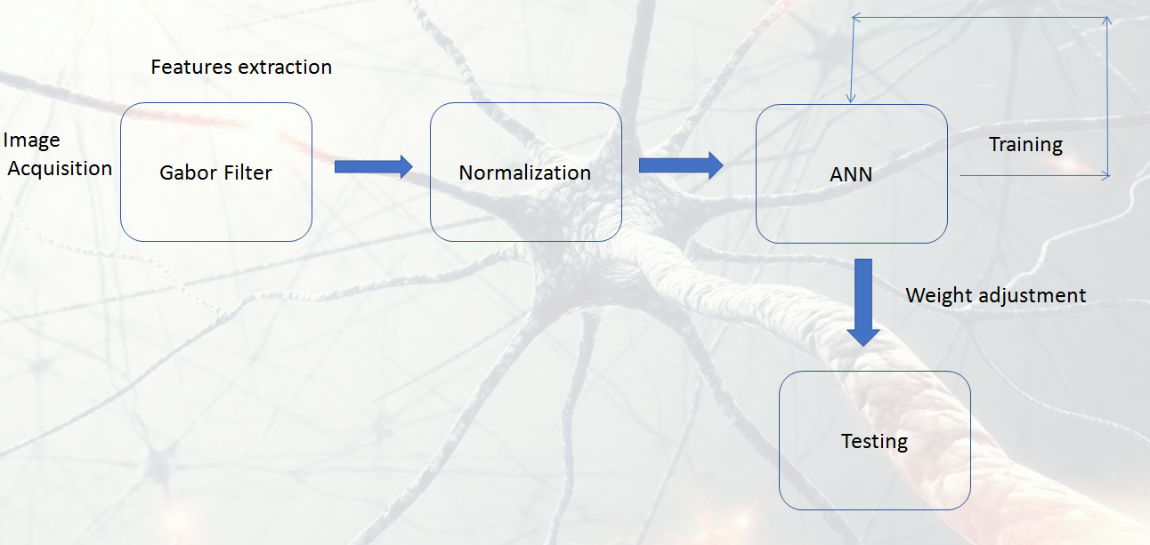
Figure 1 - Flow chart

As shown above Process sequence is shown in flow chart. It will start from the Image acquisition, Image is downloaded in specific predefined Size of 650 * 650 . If the matrix is of same dimension it will be easy for the processing. Matrix is given for Filtration procedure to take out the effective features from the image. Gabor Filter is used here for features extraction and passes it to the Normalization Stage.
In Normalization , typically 650 *650 size matrix is converted into Range -1 to 1 range. This stage Standard Deviation is used for the frame the data.
Data sheet is created with more than one example to train the Neural Network. ANN will be trained with this data sheet and adjust it multiple with data set. Last stage is testing, where trained ANN will used is trained algorithm to classify the Object into Banana or Apple.

II. Method
This Project divides into Fourth stages (i) Filtration or Features extraction (ii) Normalization (iii) Training and Finally (iv) Testing.

Image of defined size is taken in same Jpg format. All image is taken with same white background to simply the process for the initial stage. Color Image of 650 * 650 Size is taken to as data.
(i) Filtration or Features extraction - Gabor Filter is used for taking out the dominance features of image.
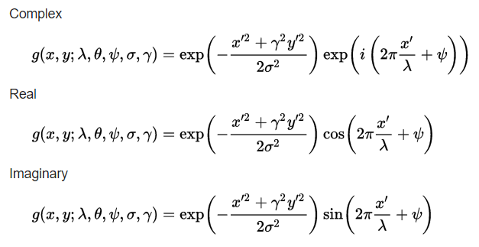
Figure 2-Gabor Filter

Above equation is the General equation of Gabor filter. It is basically the function using Gaussian Function. It has real as well as Imaginary part in the equation . It has 5 main parameter changing that parameter we can adjust the features extraction process of the Gabor Filter. This parameter included the Wavelength, Orientation , Phase , Aspect ratio, and Bandwidth.

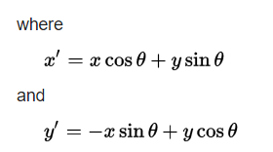
Figure 3-Gabor Filter Equation

Gabor Filter Equation we used Two parameter as key features for image Classification. Magnitude and Phase are used in the Matlab software on two image of Apple and Banana fruits

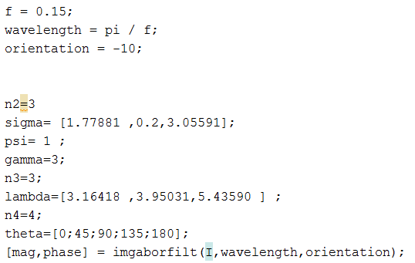
Figure 4- Matlab code for Gabor filter
After applying the above value for the parameter of Gabor filter in Matlab code we will get the result as shown Figure 5

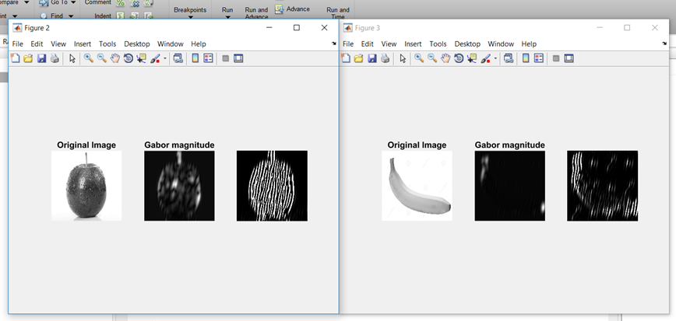
Figure 5- Gabor magnitude and Phase
From the above figures we have 2 features from the Image Gabor Magnitude and Phase.In this Project two features are taken to differentiate the object in Matlab code.This features is than hand it over for Normalization.

(ii) Normalization- In Normalization process image is converted into one value which range from -1 to 1 .For normalizaiton we are using Standard deviation function to normalize the image. ‘Std’ in build function is used in Matlab software to get the image in -1to 1 range. After normalization data sheet is made of multiple example of similar Object. Here Two fruit are taken here, 1) Apple 2) Banana. Data sheet is made using multiple example of Object
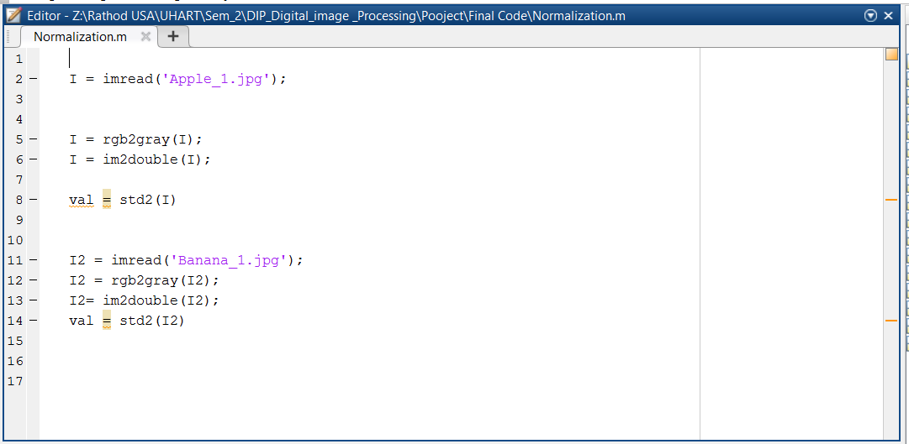
Figure 6- Normalize function in Matlab

As ANN is used as supervised learning , so predefined Data sheet is needed to train it .

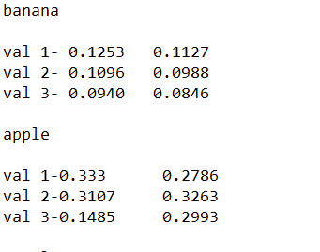
Figure 7- Data sheet for training

(iii) Training –
ANN Artificial Neural Network is made structure of 3 hidden layer ,2 input (as we have taken two Features from the object) and One Output .
Neural Network is divided basically into three layer . Input layer , hidden layer and Output layer .Depends on the complexity of the problem neurons of hidden layer is used. For this Project , Basic Structure of Neural Networking is used with Two neurons in Input layer , 3 hidden layer in the Hidden layer and One neurons of Output layer

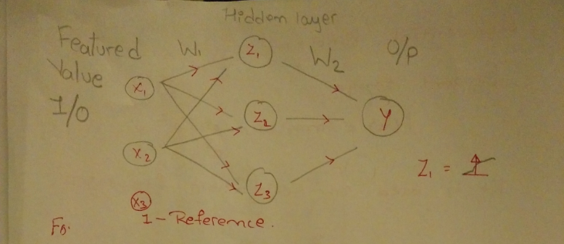
Figure 8- Neural Network Structure

ANN artificial neural network need some predefined data to get learned from the set. It will arrange its weights accordingly to get well trained
And differentiate the object. After getting train from this object ANN will able to classify the data efficiently .ANN is made up of 2 important aspect , (i) weights (synapse) (ii) Activation Function

Weights are the variable terms they will keeps on changing on every turns of cycle and keep relate them to the Output.While Activation function we
Used Tangent function.

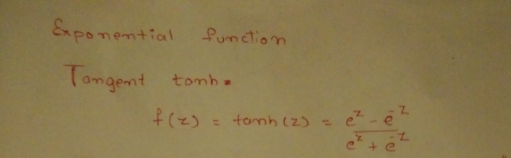

Figure 9- Activation Function

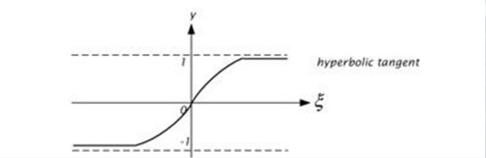
Figure 10- Tangent Graph

In Neural Network following equation is followed,
Where W is weights and F(z) is activation function

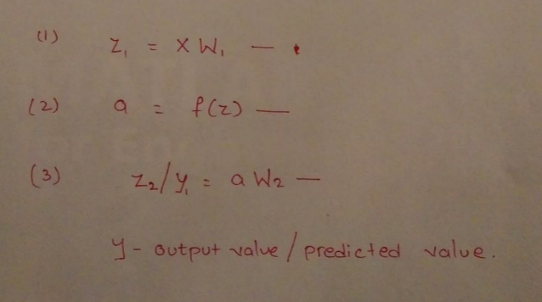

X – Input Values of Neural Network (X1,X2 )
Y – Output Value of Neural Network
W- Weight of synapses (W1,W2)
Z – Activation function

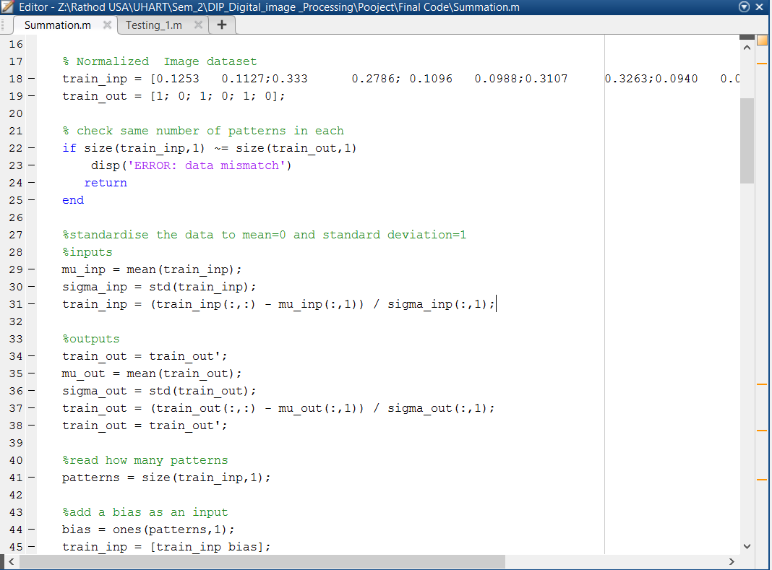
Figure 11- Training Code

Applying the Above code in the Matlab it will get train and show the graph of how much improved performance got after training.

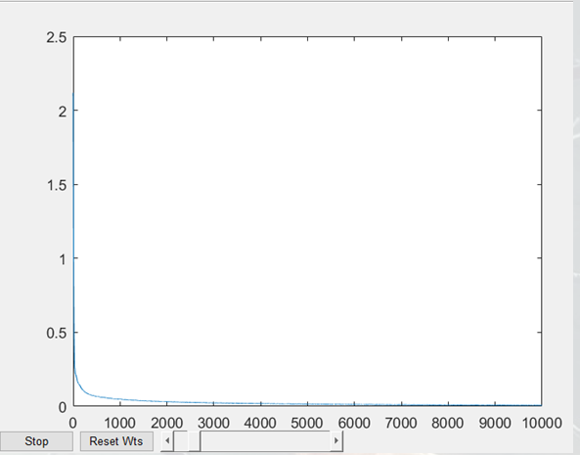
Figure 12- Error Graph
Graph shows starting period of pproach Error was quite high ,as it went toward X axis it will decrease the error in almost to Zero.
Figure 13 shows the value of error we are getting after training the Neural Network

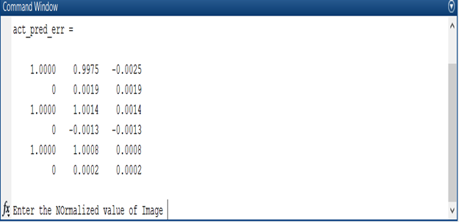
Figure 13 Prediction result

(iv) Testing- In This stage Standard deviation value of Any of two Fruits image matrix is given as the input to the ANN , it will use the Trained algorithm
to classify the fruit and show in Screen with Image.
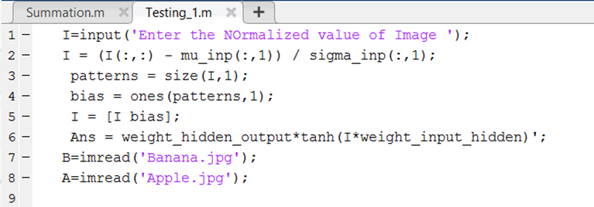
Figure 14- Testing
(III) Conclusions
From this Project We applied the Object detection concept to classify two fruits , we can further apply this algorithm into object detection in Cluster of many object. Here Neural Network and Gabor filter is used to take features and used as Data input to classify the Two fruits .

Acknowledgment
The heading of the Acknowledgment section and the References section must not be numbered.
References
- https://www.mathworks.com/discovery/object-detection.html
- http://neuralnetworksanddeeplearning.com/chap1.html
- https://cvtuts.wordpress.com/2014/04/27/gabor-filters-a-practical-overview/
- http://stackoverflow.com/questions/33610825/normalization-in-image-processing
- https://www.youtube.com/watch?v=bxe2T-V8XRs&list=PLZL4viv3ev40yhRckY_nipd0368rG8rnu

- https://anoopacademia.wordpress.com/2013/09/29/back-propagation-algorithm-using-matlab/comment-page-1/#comment-271

